EXPERIMENT -25.

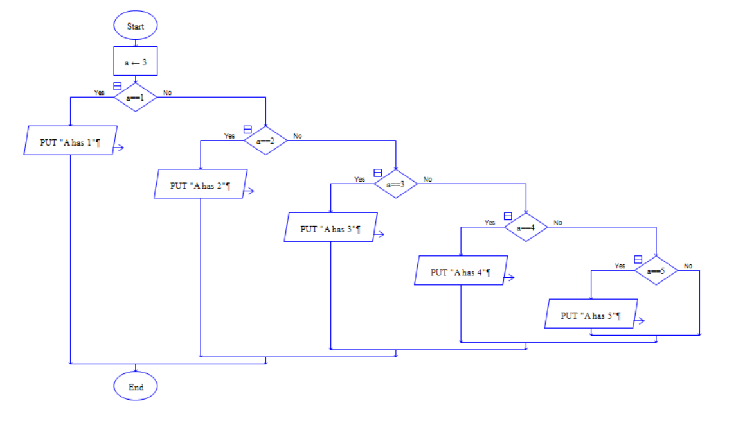

Output:

